
Final Exam
Name ________________________________________________________________________
ID number __________________ Date _________________ Group ________
“Adhering to the Code of Ethics for students of the Tec de Monterrey, I pledge to follow the precepts of academic honesty in this evaluation by not using unauthorized or illicit resources to solve it.”
_________________________________
Signature

Multiple choice
Domain and range

Algebra Skills
Composition of functions
Operation with functions
Inverse functions

Function analysis
Find asymptotes
Graph functions
Find discontinuities
Find roots

Modeling with math
Cost
Exponential Decay
Piecewise function

Conic Sections

Identify the conic section given the general equation
Graph conic sections

Evaluation of Functions
- Read the following questions and identify the option that best answers each, then write its letter on the line. (3 points each)

- Evaluate the following function: $f\left(4\right)=5x+1$
- 21 b) 14 c) 10 d) 31 _______

- Evaluate the following function: $g\left(3\right)=x^{2}-7$
- -4 b) 2 c) -2 d) 4 _______

- Evaluate the following function: $h\left(-3\right)={\left(x-2\right)}^{3}$
- -2 b) -125 c) -25 d) 45 _______
Operations with functions
1. Combine the functions according to the indicated operation. (3 points each)
$f\left(x\right)=x^{2}+2$ $g\left(x\right)=x-3$
- Operation 1: $\left(f+g\right)\left(x\right)$

- Operation 2: $(f-g)(4)$

- Operation 3: $(f*g)(-5)$

- Operation 4: $\left(\frac{f}{g}\right)(0)$ and state its domain.

2. Combine the functions that model a real-life situation. (10 points)
A small publishing company is releasing a new book. The production costs will include a one-time fixed cost for editing and an additional cost for each book printed. The total production cost C (in dollars) is given by the function $C=660+14.95N$, where N is the number of books.
The total revenue earned (in dollars) from selling the books is given by the function $R=32.80N$.
Let P be the profit made (in dollars). Write an equation relating P to N. Simplify your answer as much as possible.

Composition of functions
1. For the following pair of functions, find the indicated composition. (3 points each)

Functions:
$f\left(x\right)=\frac{5x}{x+2}$ $g\left(x\right)=\frac{8}{x}$

- $\left(f∘g\right)(x)$ and its domain

- $\left(f∘f\right)(x)$

- $(g∘g)(2)$

Inverse Function
1. Graph the given function and state its domain and range. Then, graph its inverse and state its domain and range. Finally, graph the reflection line. (10 points)
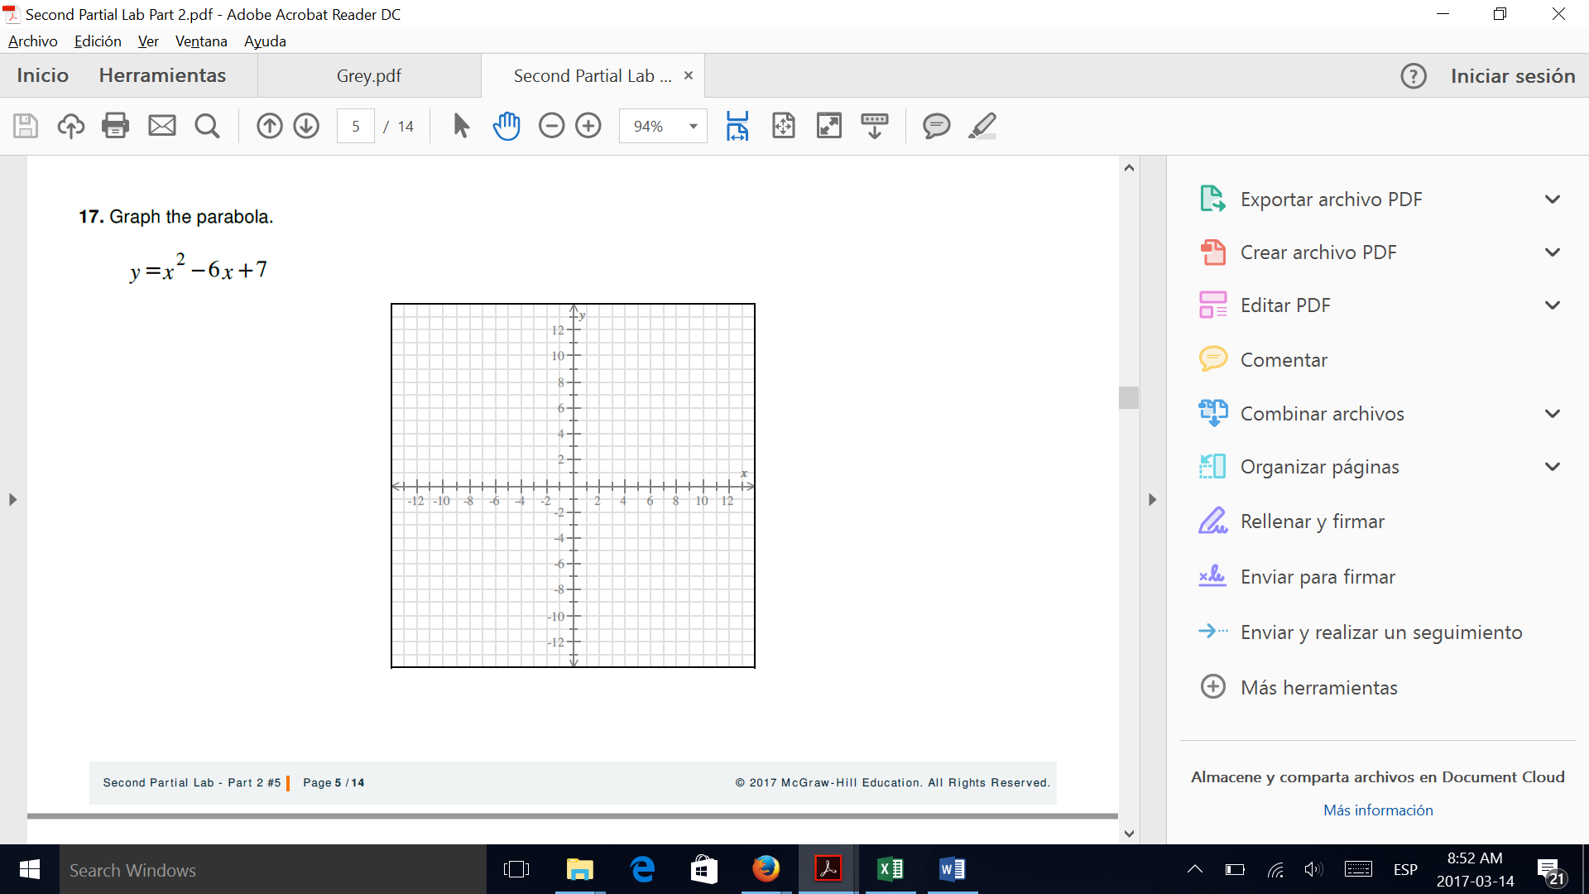
a. fx=2-x

domain: ____________________
range: __________________

Inverse function: ______________________
Domain of $f^{-1}\left(x\right)$: ___________________________
Range of $f^{-1}\left(x\right)$: ____________________________

Rational Functions
1. Given the following functions find the vertical and horizontal asymptotes, the empty point (hole), and the x and y intercepts. Then, graph the function and state its domain and range. (10 points)

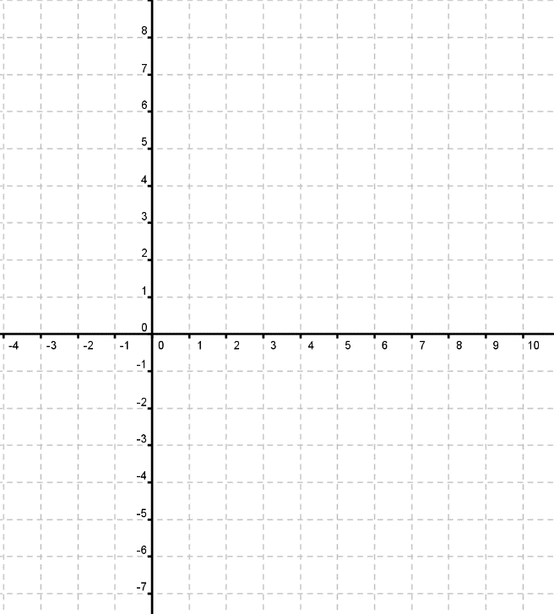
a) $y=\frac{2x-4}{2x^{2}+x-10}$

VA:____________
HA: ____________
“Y” intercept: _____________
“X” intercept: _______________
Hole:__________
Domain: _________ Range: _____________

Exponential Functions
Given the following functions find the asymptote, and the critical point. Then, graph the function and state its domain and range. (10 points)
a) $y={-e}^{x+1}-2$
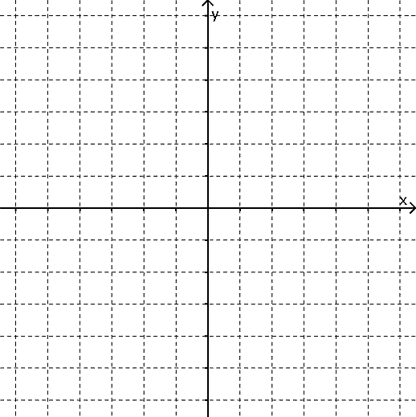
Asymptote: ____________
Critical point: _____________
Domain: ____________________
Range: _____________________

Exponential and Logarithmic Equations. Solve the following equations. ( 5 points each)

a) $\log{(3-x)}-\log\left(x+9\right)=0$

b) $e^{x^{2}+6}=e^{x}$

Solve the following problem. (5 points)
The initial frog population in a small pond is 75 frogs, and the annual growth rate is 18% .
a) Write the model (function) of the population “p” after “t” years.

b) Calculate the expected population after 3 years.

c) Calculate the number of years needed for the frog population to be 540.

Conic Sections
1. Graph the conic section and state which kind of conic section it is. (5 points each)
a) $\frac{{\left(x+3\right)}^{2}}{25}+\frac{{\left(y-2\right)}^{2}}{9}=1$

b) $16x^{2}-9y^{2}-96x-54y-81=0$

Write the general form equation from the following graphs and state which kind of conic section it is. (5 points)

